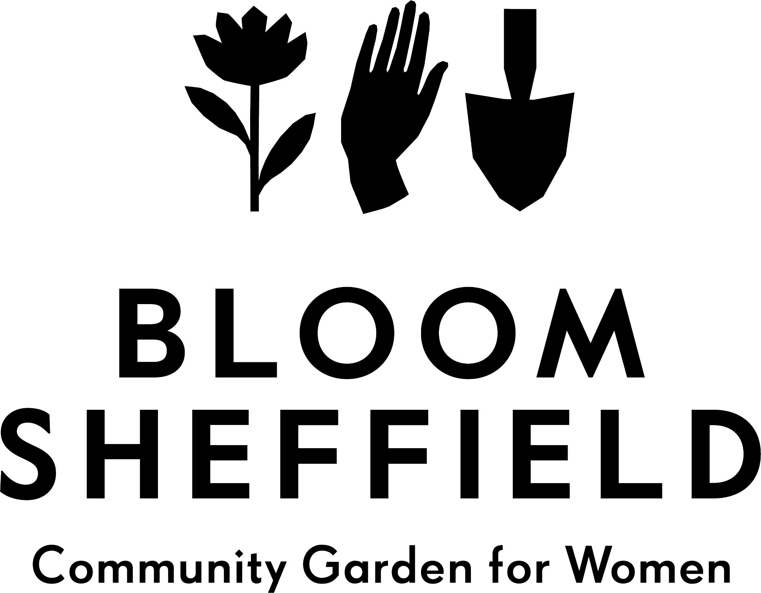

Referral Form for Health Care Professionals

Referrals can be made for all women and non-binary people who need support maintaining their mental health and would benefit from spending time in, and contributing towards, a community flower garden. Please note we are a trans-inclusive space.

Please fill out as much detail as possible and return to Kate Evans on kate@bloomsheffield.com. If you have any questions please do not hesitate to contact us.

Date:

Person being referred
Full name:
Age and date of birth:
Ethnicity:
Address and postcode:
Phone number:
Email address:

Caring Status (Complete as appropriate)
- Has a carer
- Is a carer
Name and contact details of main carer:

Nature of mental health difficulty, including details of any on-going risk of self-harm or harm to others, effects of medication etc.

Nature of any physical health problems that we need to take into consideration.

Any other information that may affect the person’s ability to attend Bloom Sheffield’s activities e.g. drug/alcohol use, criminal convictions, language barriers.

Referrer details
Name of referrer:
Organisation:
Relationship to person being referred:
Email: | Phone number:

